FOR SALE

2x Used Yamaha HS5 Powered Studio Monitor

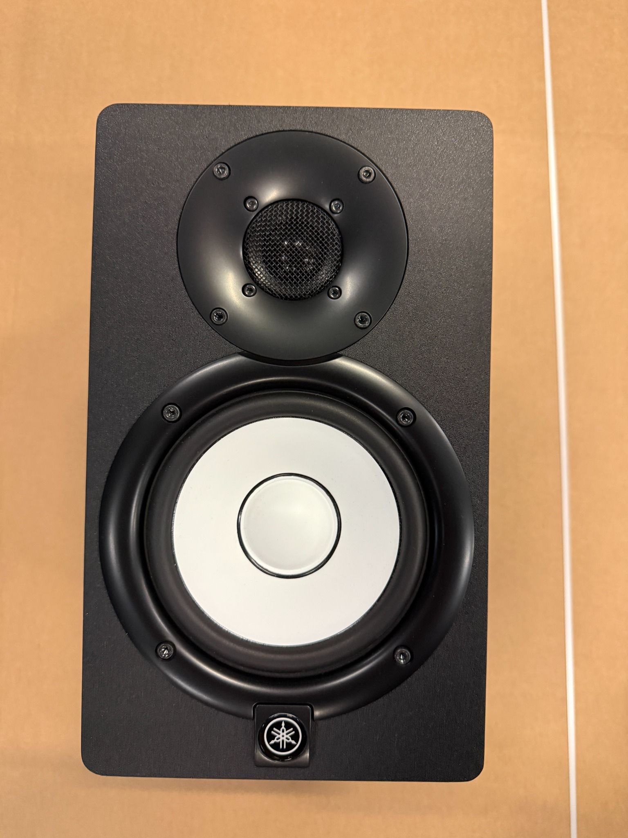

Compact Yamaha HS5 powered studio monitor for nearfield monitoring, music production and editing workflows.

Use case: Nearfield studio monitor for recording, editing, mixing, content creation and multimedia production.
General features: 2-way powered speaker system with 5-inch woofer, 1-inch tweeter, rear bass-reflex port, front HS-series driver layout, level control, room control and high trim adjustment.
Connections: Balanced XLR input, balanced 6.3 mm jack input, IEC AC power input and rear power switch.

Rear View:

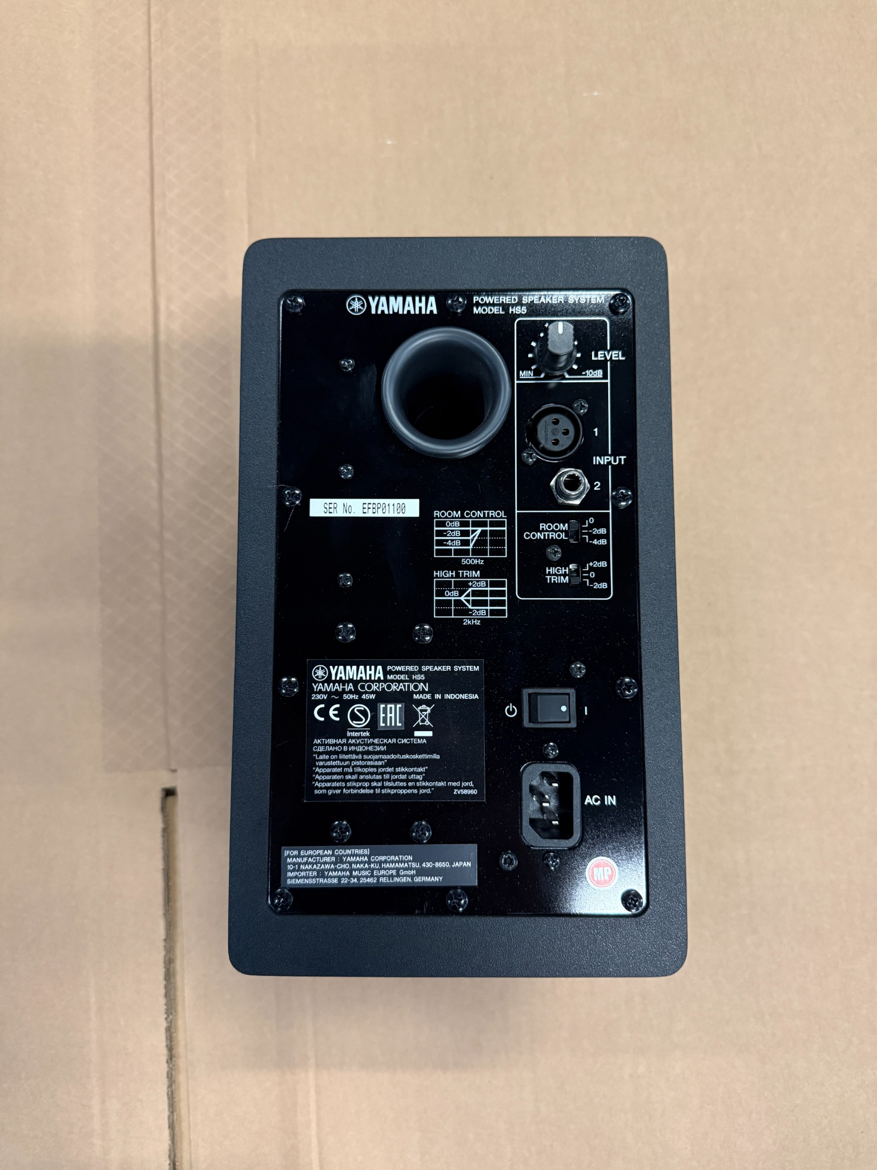

Price on request:
Excl. VAT
Excl. shipping & insurance costs
Excl. custom fees

For further information please contact:
Otmar Valzachi
sports tv media distribution GmbH

Paradeisergasse 9
9020 Klagenfurt
AUSTRIA

Tel:+43 463 908000
Fax:+43 463 908000 99
Mobile:+43 676 848606211
email: ov@stvmd.com
http://www.stvmd.com

