FOR SALE

Used Musikelectronic Geithain RL906D

Active Studio Monitors - up to 12 units available

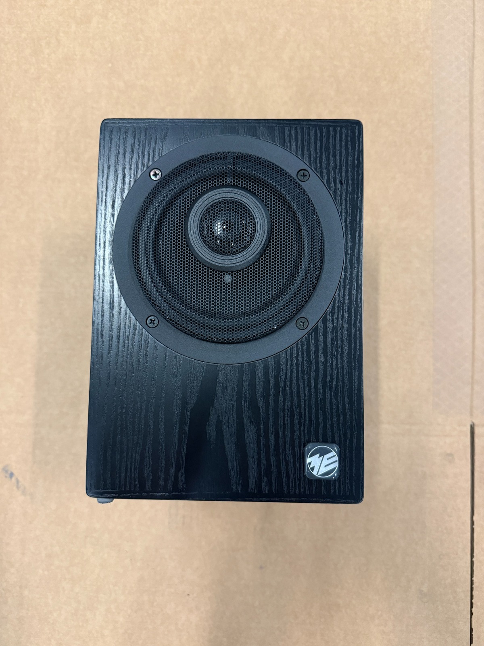

Equipment details:

The Geithain RL906D is a professional compact active reference monitor designed for critical listening environments such as broadcast control rooms, editing suites, recording studios and post-production facilities. Its compact cabinet, front-mounted coaxial driver layout and rear-panel digital / analog input options make it suitable for accurate nearfield monitoring in demanding professional applications.

Key Facts:
Manufacturer: musikelectronic geithain GmbH, Germany
Model: RL906D / Regielautsprecher RL906D
Category: Active compact reference monitor / nearfield studio monitor
Application: Broadcast control rooms, editing suites, recording studios, post-production facilities and professional audio monitoring
Design: Active compact monitor with front-mounted coaxial driver layout
Available quantity: up to 12 units
Rear controls: HT, TT, 300 Hz and level adjustment
Input options: digital AES/EBU and balanced analog input, selectable on the rear panel
Connection: balanced XLR input
Power: AC 50-60 Hz, max. 100 VA
Made in: Germany

Product Views:
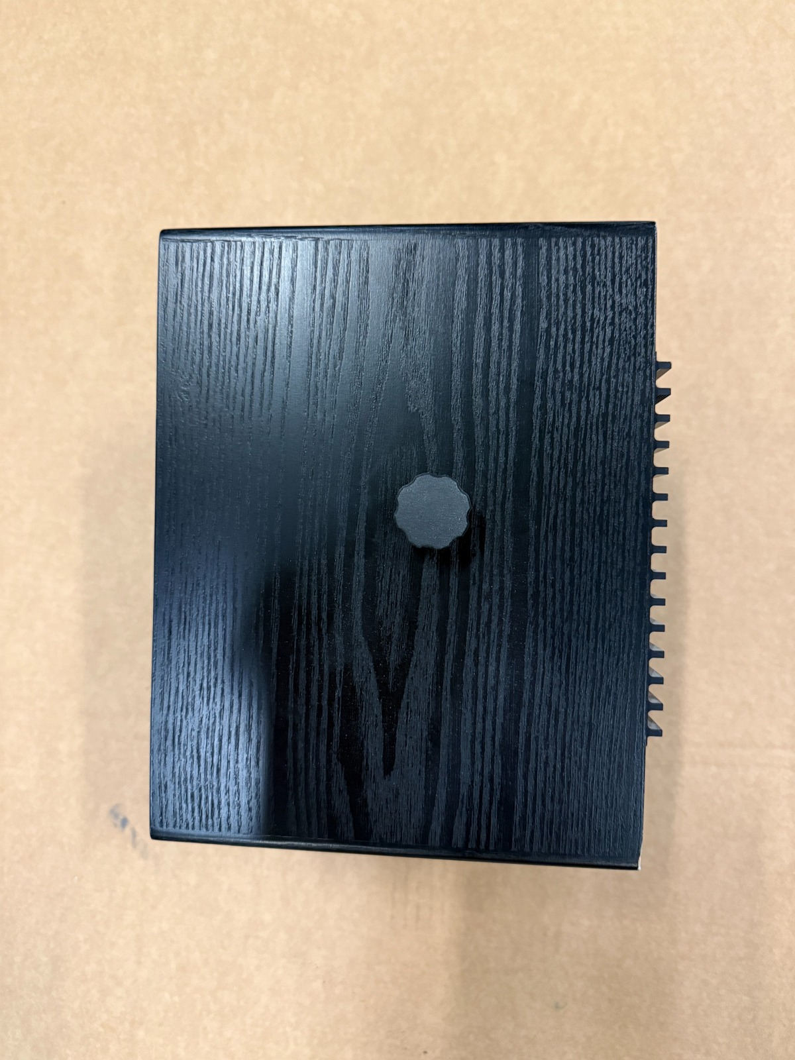
Rear / bass reflex port view
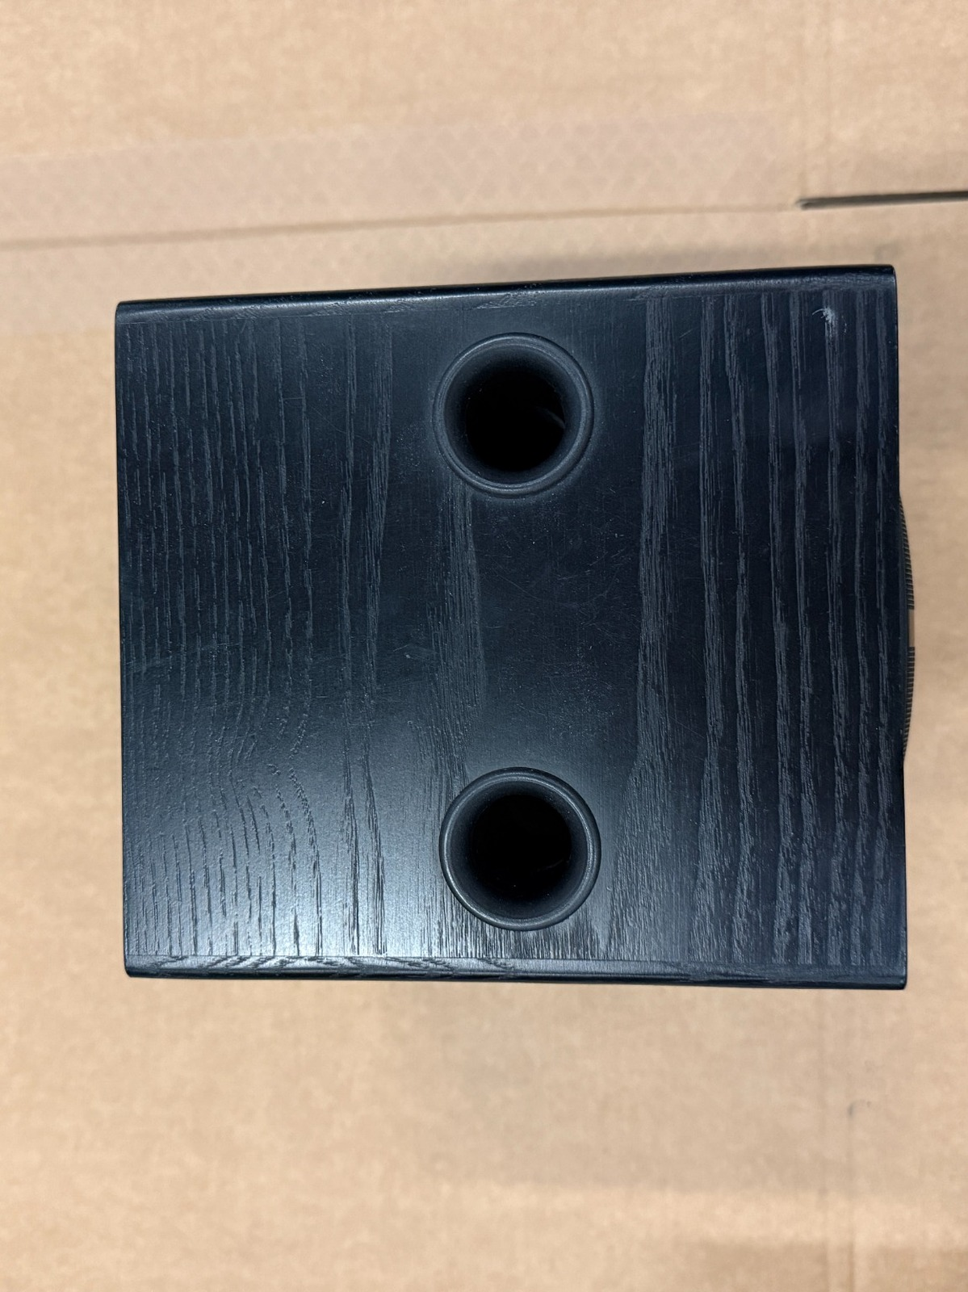
Rear panel / controls and connection close-up
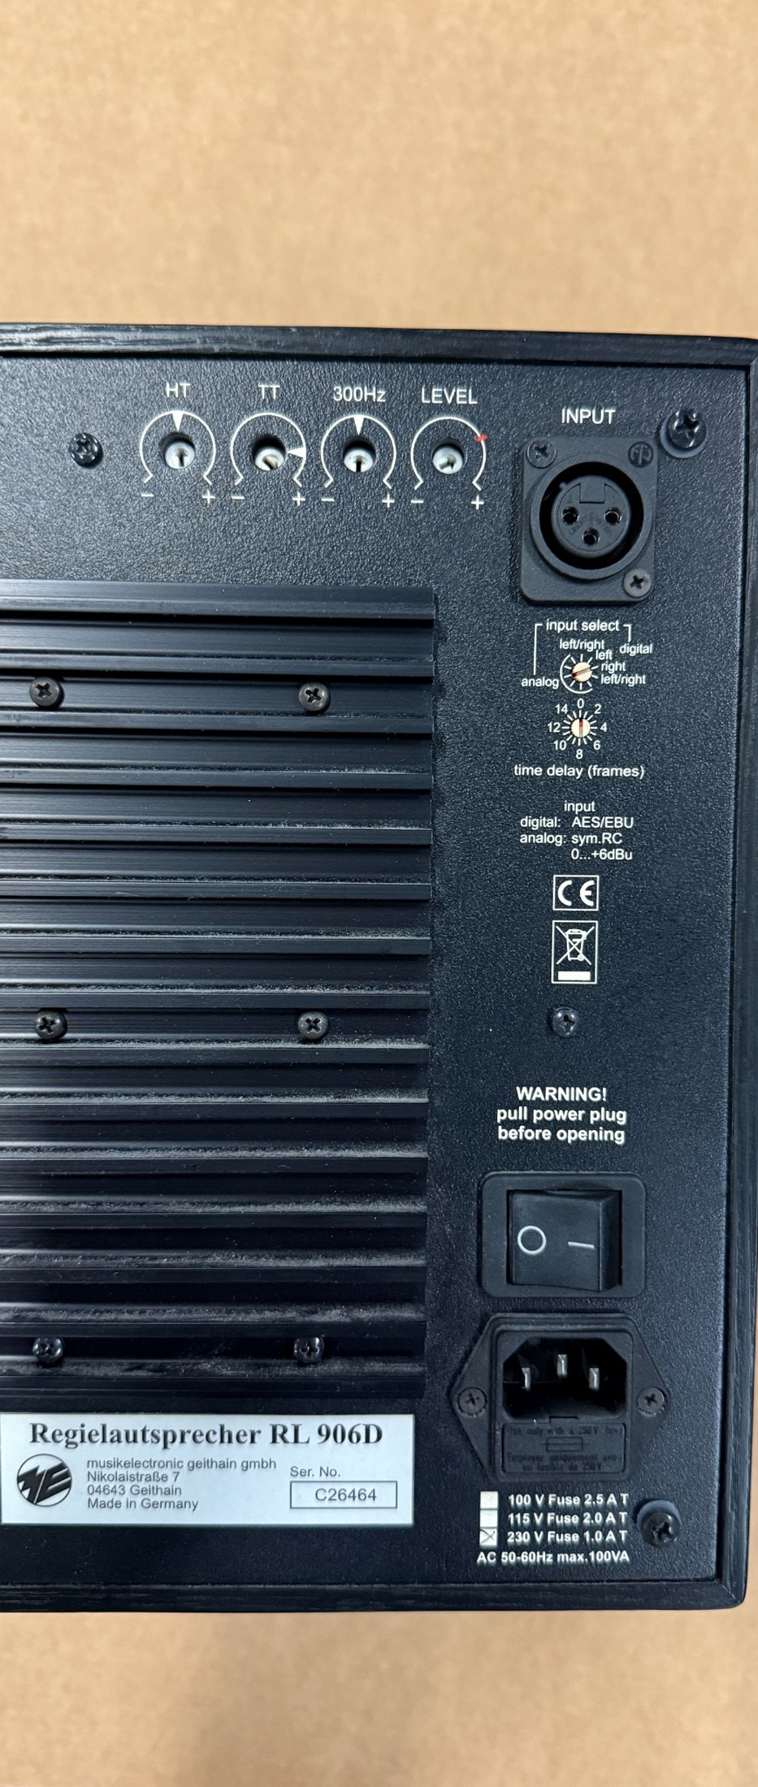

Price on request:
Excl. VAT
Excl. shipping & insurance costs
Excl. custom fees

For further information please contact:

Otmar Valzachi
sports tv media distribution GmbH

Paradeisergasse 9
9020 Klagenfurt
AUSTRIA

Tel:+43 463 908000
Fax:+43 463 908000 99
Mobile:+43 676 848606211
email: ov@stvmd.com
http://www.stvmd.com

